**DAILY ONLINE ACTIVITIES SUMMARY**

|  |  |  |  |  |  |  |  |  |
| --- | --- | --- | --- | --- | --- | --- | --- | --- |
| **Date:** | **16/07/2020** | | | | | **Name:** | **SPOORTI DAROJI** | |
| **Sem & Sec** | **4th SEM. & ‘B’ SEC.** | | | | | **USN:** | **4AL18CS088** | |
| **Online Test Summary** | | | | | | | | |
| **Subject** | | **-----** | | | | | | |
| **Max. Marks** | | **--** | | **Score** | | | **--** | |
| **Certification Course Summary** | | | | | | | | |
| **Course** | **Programming for Everybody (Getting Started with Python)** | | | | | | | |
| **Certificate Provider** | | | **Coursera** | | **Duration** | | | **7 weeks** |
| **Coding Challenges** | | | | | | | | |
| **-----** | | | | | | | | |
| **Status : --** | | | | | | | | |
| **Uploaded the report in Github** | | | | | **Yes** | | | |
| **If yes Repository name** | | | | | **-----** | | | |
| **Uploaded the report in slack** | | | | | **Yes** | | | |

**Online Test Summary: No internals conducted.**

**Online Certification course Summary:In today's session I learnt why this programming language is named as python. Python was not named for a snake even though we use the snake motif all the time. It turns out that Python was named for Monty Python's Flying Circus. And the reason was that Guido was trying to capture an air of play.**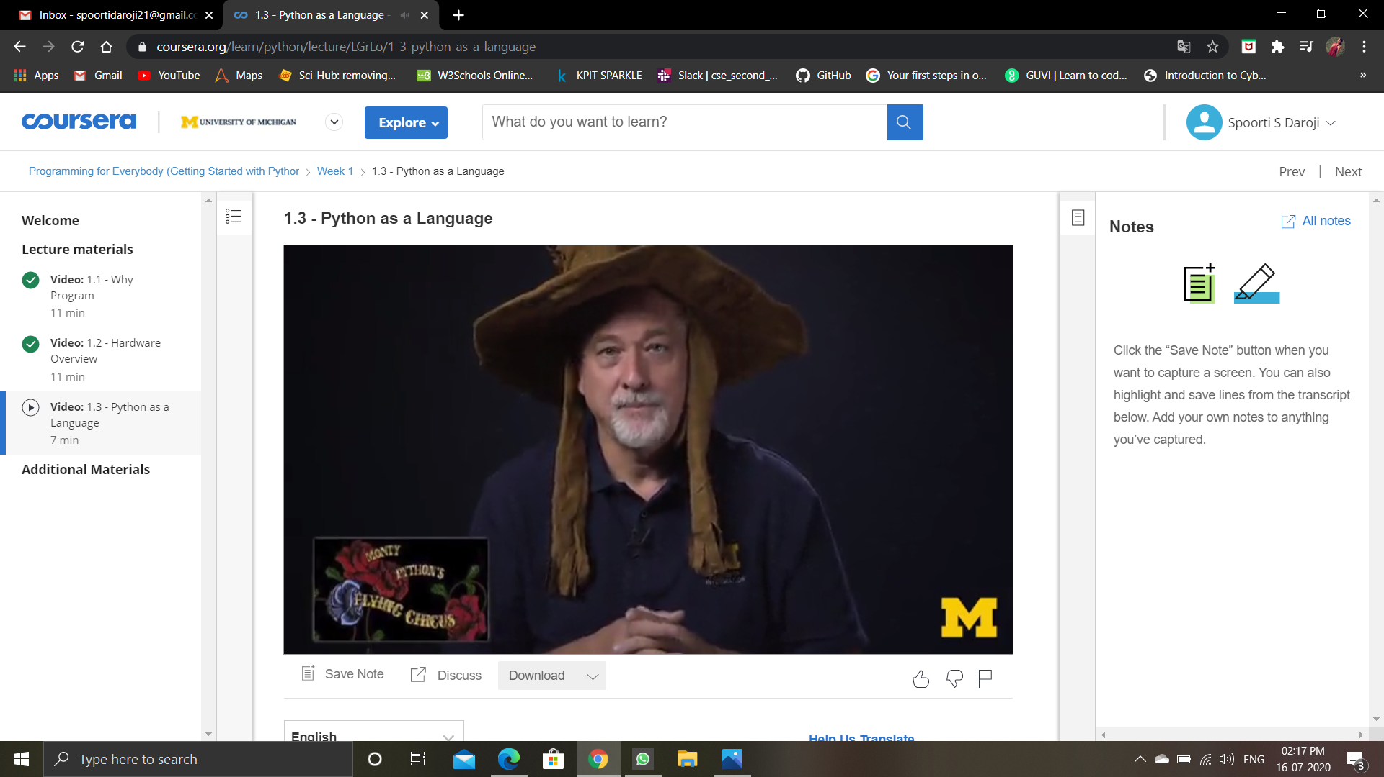

**And I learnt How to install atom on my pc.**

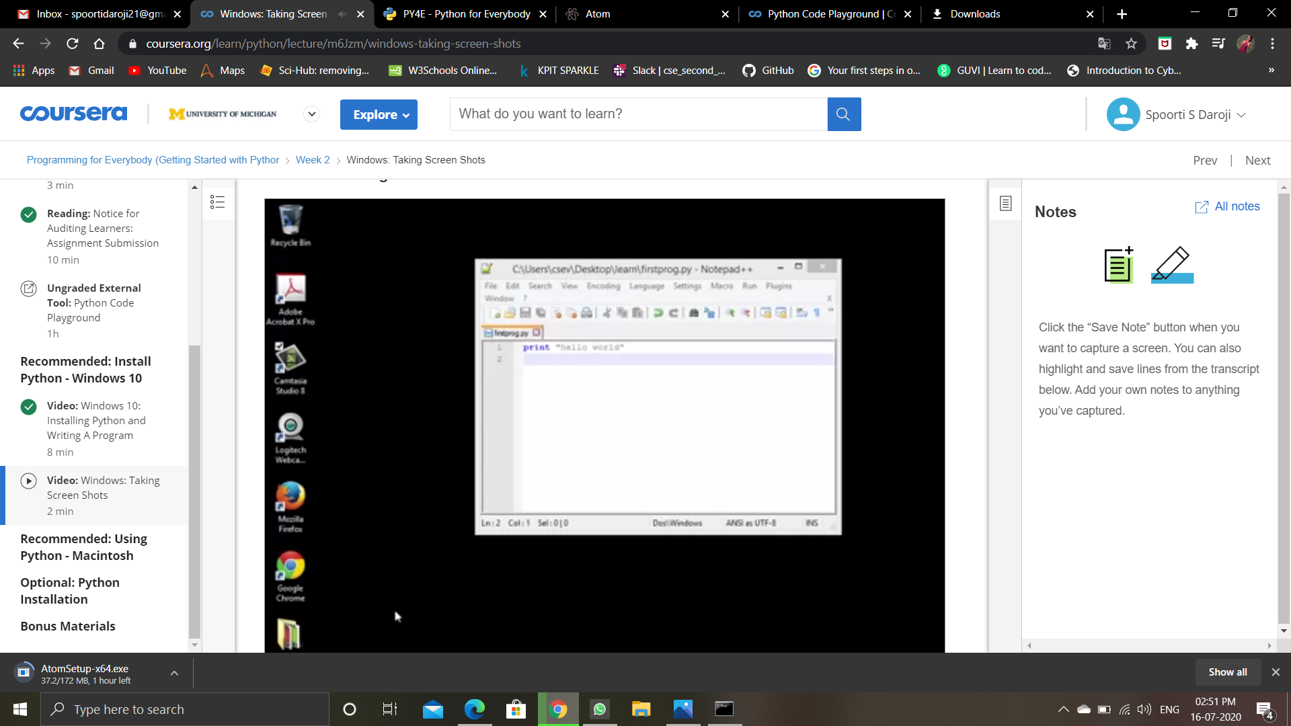

**And this is the first assignment solved on coursera.**

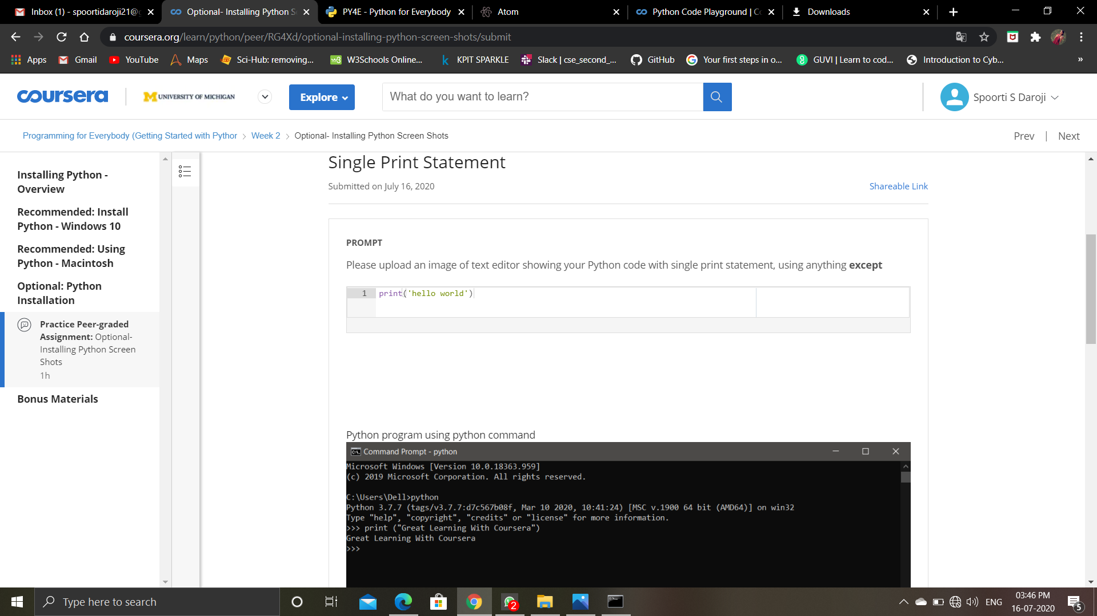

**Online Coding Summary: Didn’t receive any program.**